**Institute of Technology Tralee**

**Ord/Hons BSc. in Computing with Specialism (Group 1) - Year 1**

**Continuous Assessment #2**

**Date: 24/3/14**

**Time: 2 p.m. – 4 p.m.**

**Object Oriented Programming 1**

**Instructions:** Attempt the following question. You should use the JCreator IDE. When you are finished coding, print out your code in **landscape** format.

**________________________________________________________**

**Q1.**

A Java program is required that will read in the username and password combinations of 5 people, using a **for** loop. You can take it that the user will enter a valid username each time, but each password must be fully validated to ensure it complies with the following criteria:

* must have a minimum of 8 and a maximum of 15 characters in total
* must only contain letters or digits
* must contain at least 3 digits

The user will keep getting issued with a suitable error message until they enter a valid password. The error message will indicate a reason why the password was invalid.

Once all 5 valid username/password combinations have been entered, they will then be displayed neatly aligned via a text-area on a message dialog. You can take here it that the longest username will be 25 characters. On your text-area, you can display the information using a “monospaced” plain font with a point size of 11.

For full marks here, your program should, along with a logically correct solution for the problem above, include the usual **single-line** and **multi-line comment** at the top of the program. The multi-line comment should briefly explain the purpose of the program.

Your program should run as indicated in the following sample screenshots. Also, you can use the test values indicated when testing your own program.

**Sample Screenshots**

**The main loop begins by asking the user to enter the first username and password. Here, several invalid passwords are entered and an appropriate message gets issued to the user indicating the problem, asking them to re-enter.**

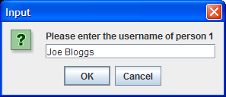 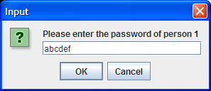

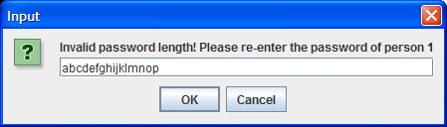

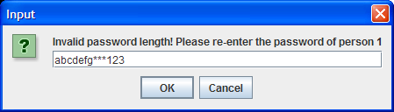

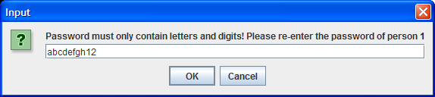

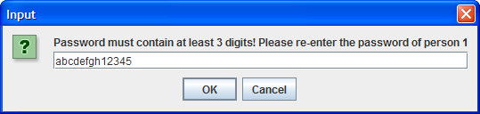

**Finally, a valid password is supplied and the main loop progresses to ask for the second username.**

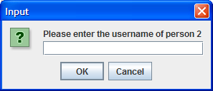

**…. more input and validation follows and finally, when the main loop has finished, the program displays the following message dialog:**

